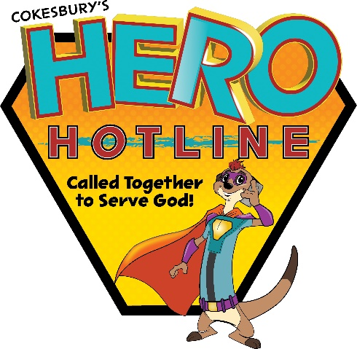
Registration Form
(One Per Child)

Pre-registration requested by July 26, 2023.
Complete one form per child.
Forms can be dropped off, mailed to: VBS Good Shepherd Free Lutheran Church
c/o Kailee Byrd
5939 Oliver Ave SW, Cokato, MN 55321 or email to: secretary@goodshepherdcokato.com

Child’s name: _____________________________________
Boy or Girl: _____________ Child’s age: ___________
Date of birth: ___________ Last school grade completed:___________
Name of parent(s):______________________________________________
Street address:__________________________________________________
City:____________________________ State: ______ ZIP:___________
Parent/caregiver’s cellphone: ( )____________________
Home email address:______________________________________
Home church:__________________________________________
Allergies, medical conditions, or special needs:_________________
______________________________________________________________
In case of emergency, contact:____________________________________
Phone:_________________________________________
Relationship to child:_________________________________
Yes - or - No (please circle) Can Good Shepherd use your child’s photo for purposes relating to VBS, including but not limited to social media and/or church website?

